***Microsoft Power Pages***



***Table of Contents***

Introduction…………………………………………………………………………………………………….........3

Power Pages and PowerApps Portals…………………………………………..……………………………...4

Power Pages Capabilities………………..…………………………………………..……………………………...6

Getting Started with Power Pages………………..…………………………….………………………..……...9

Create and Add a Form………………………………..…………………………….………………………..…….14

Permissions in Power Pages ………………………………..………………………………………………..…….17

Licensing ………………………………..…………………………………………………………………………..…….21

Licensing details PowerApps Portals ………………………………………………………………….……..….21

Some FAQ’s on PowerApps Portals Licensing ………………………………………………………..…..….22

References……………………..………………………………..…………….……………………………………..…….24

Document Version History………………………………..…………….……………………………………..…….25

***Introduction***

* Microsoft Power Pages is a latest addition to Microsoft Power Platform.
* This is a Software as a Service, a low code scalable platform. It helps to build external facing websites quickly , seamlessly and can be accessed via all browsers and mobile devices.
* Power Pages is an enterprise level , secure platform for creating , hosting and administering modern external- facing business websites.
* Power pages allows one to design , configure and publish websites that work across web browsers and devices.

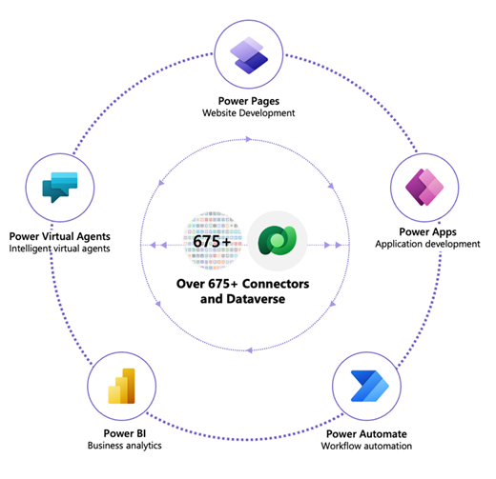

**Screenshot 1. Power Platform Family with Data verse as a Database**

* Power Pages gives an ability to create rich, customizable templates, a fluid visual experience through a reimagined design studio, and a new, integrated learning hub to quickly build sites that suit your unique business requirements.
* With Pages , we can built sites using the same data , which is stored in Data verse for business needs , which is also used for Power BI Reports, building workflows etc.
* There is no much difference between Power Pages and PowerApps Portals , it can just be considered as a brand name change. Let’s study more in detail about the same.

# **Power Pages and PowerApps Portals**

* Power Pages is an evolution is Power Apps portals. It is built on top of PowerApps Portals , which is used by many organisations.
* Power Pages is combined with the new low-code , no code approach to give everyone an opportunity to build the websites and use them for their businesses. The new low code Power Pages platform does not require a lot of coding and anyone who has good knowledge on the power platform can start creating these secure websites.
* Power pages not only allows anyone to create the websites and pages quickly , but it also allows pro developers to have extra features such as , using VS Code Editor , allows to add code components and gives ability to use Power Platform CLI.

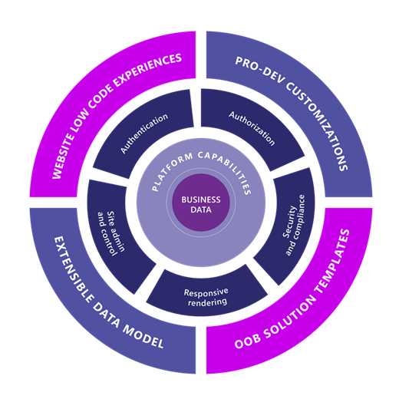

**Screenshot 2. Figure showing the different capabilities of Power Pages**

* Power Pages is a superset of PowerApps portals.
* Current users of Power Apps portals does not need to upgrade or migrate to Power Pages.
* Also the planned projects , and solutions can also continue to work with PowerApps portals since , it won’t affect their solutions with the introduction of Power Pages.
* Along with the extensible data model and pro developer customization experiences of Power Apps portals, Power Pages adds new low-code experiences and out-of-the-box solution templates.
* Some of the following features of Power Pages are available for preview.
* [New design studio with productivity workspaces](https://docs.microsoft.com/en-us/power-pages/getting-started/use-design-studio)
* [Improved trial and site creation experience](https://docs.microsoft.com/en-us/power-pages/getting-started/trial-signup)
* [Templates hub](https://docs.microsoft.com/en-us/power-pages/templates/)
* [Learn hub](https://docs.microsoft.com/en-us/power-pages/getting-started/use-learnhub)

When Power Pages becomes generally available, the current configuration and developments done with Power Apps portals will automatically be fully compatible with Power Pages.

# **Power Pages Capabilities**

One can quickly develop professional looking website and web pages which suites their business needs.

1. **Simplified Maker Experience**

If your business needs satisfy the requirements from an existing template from Power Pages , then you can start building the website quickly making use the templates provided and make customisations by editing as per your need.

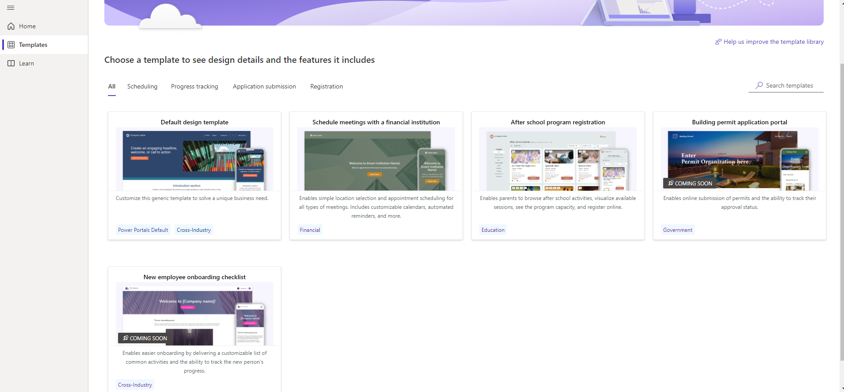

**Screenshot 3. Screenshot displaying different templates available to start building the website**

1. **Design Studio**

Power Pages allows the user to create powerful pages without having to write a single line of code. It has all been configured with Low code options.



**Screenshot 4. Screenshot displaying different Capabilities and the maker Experience in Power Pages**

On the left side we have the option for styling and Data. The data is stored in Microsoft Data verse , and by default it has all the columns based on a particular site template , we can customise it as per out needs. These can be specified as different sections,

* **Pages Workspace :** This allows one to create pages , design pages and arrange pages .
* **Style Workspace :** As highlighted in the left pane , we can select the styling option and make the necessary changes in the style.
* **Data :** for creating and modifying Microsoft Data verse tables are used in data-driven web applications.
* **Set up :** It provides options for administration and site management.

1. **Responsive Rendering**

Power Pages is based on Bootstrap, which natively provides support for building websites that are responsive, mobile-friendly, and available in various form factors.

1. **Advanced Development Capabilities for Pro developers**

Makers can work with pro developers in fusion teams to extend the functionality using Visual Studio Code and the Microsoft Power Platform CLI to create powerful business application websites.

1. **Security and Governance**

Power pages has built in security. Organisations can give access to their data to users based on the roles to internal and external users.

* Organizations using Power Pages can select from various authentication providers or allow access to site content anonymously.
* Power Pages is hosted as Azure App Service, which has International Organization for Standardization (ISO), System and Organization Controls (SOC), and Payment Card Industry Data Security Standards (PCI DSS) compliance.
* Power Pages supports modern TLS crypto standards (TLS 1.2) and has built-in Azure DDoS protection. It also supports dynamic IP restriction to limit traffic from bad actors and provides secure, configuration-driven mechanisms for admins to address top web security vulnerabilities such as injection attacks, cross-site request forgery, and server-side request forgery.
* You can also configure Power Pages to use edge caching and web application firewall (WAF) capabilities.
* Power Pages provides some helpful tools for administrators to manage the administration and lifecycle of their sites and environments.

1. **Integration with Other Power Platform Components**

Power pages provides the feasibility of integrating it with other Power Platform components.

* **Dataverse** – Dataverse is used to store and manage the data We can make use of Model-driven apps
* **Power Apps –** This enables to create quick low code mobile app solutions, using which we can store the data in SharePoint , and use it within the organisation effectively.
* **Power Automate** – Helps in automation off various tasks. With Power Pages, use Power Automate for plug-ins, workflows, automated cloud flows, or to extend business logic and interact with data and events coming and going in and out of Dataverse.
* **Power BI** - allows anyone to access visually effective and interactive insights from business data. With Power Pages, integrate with Power BI dashboards and reports to make the Power Pages more effective.
* **Power Virtual Agents** enables teams to easily create and publish AI-driven chatbot experiences. With Power Pages, add chatbots to your external-facing websites for a myriad of business purposes.

# **Getting Started with Power Pages**

If one wants to get started with Power Pages , he can simply visit make.powerpages.microsoft.com or <https://powerpages.microsoft.com/>.

It navigates the user to the Power Pages Preview Site as shown in the below screenshot.

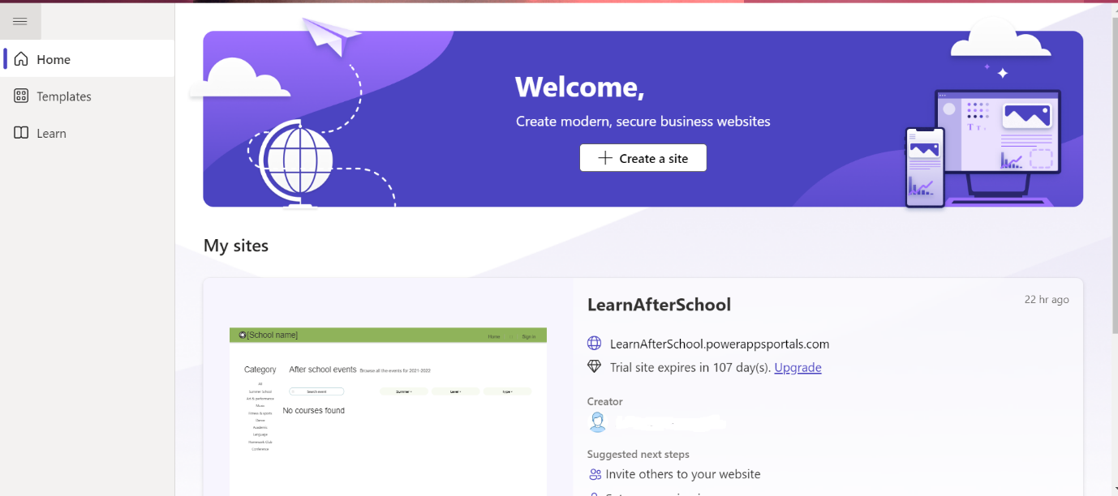

**Screenshot 5. Screenshot showing the landing Page of Power Pages.**

The landing page gives us an option of Templates if we check the left navigation. Templates are built have built-in pages which might suite one’s business requirement.

Also, if one wants to go through the Microsoft documentation and Learn, Power Pages with videos and documentation, they can follow if from the Learn tab.

To get started with the Website Creation using Power Pages , click on **Create a Site ,** select a template , now it will give us an option to give the Site a name and also asks for a web address.

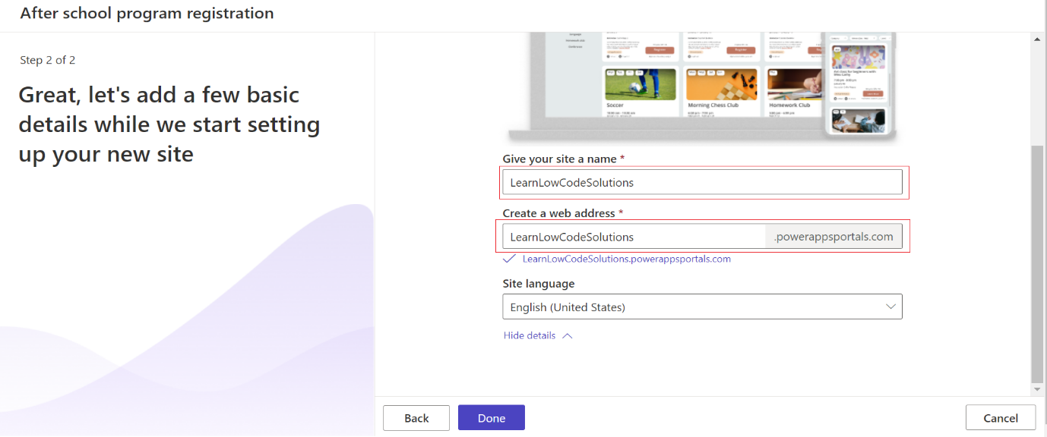

**Screenshot 6. Screenshot showing the option to select the site name and Web address .**

Once you click on Done , it starts creating the site .

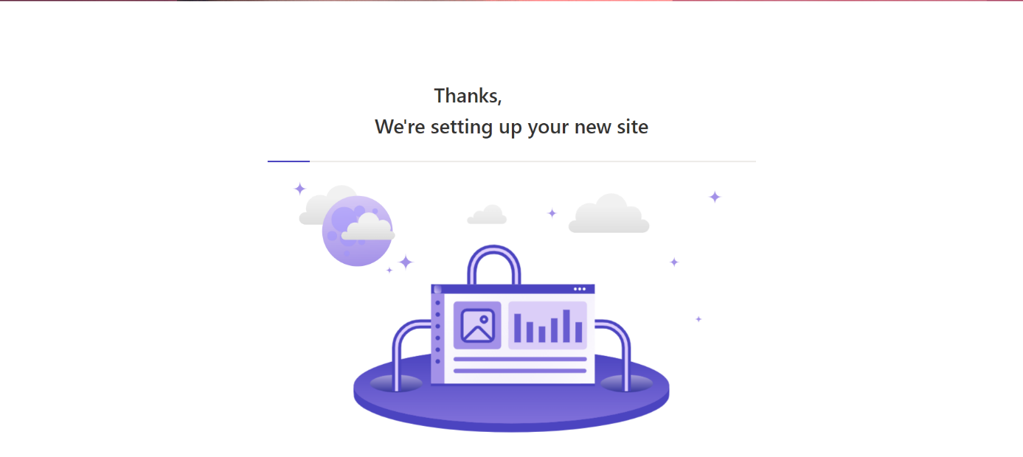

**Screenshot 7. Screenshot showing the setting up of the new site**

The lands the use into a maker experience in Power Pages and the user can then make the changes as per the need or the business requirement.

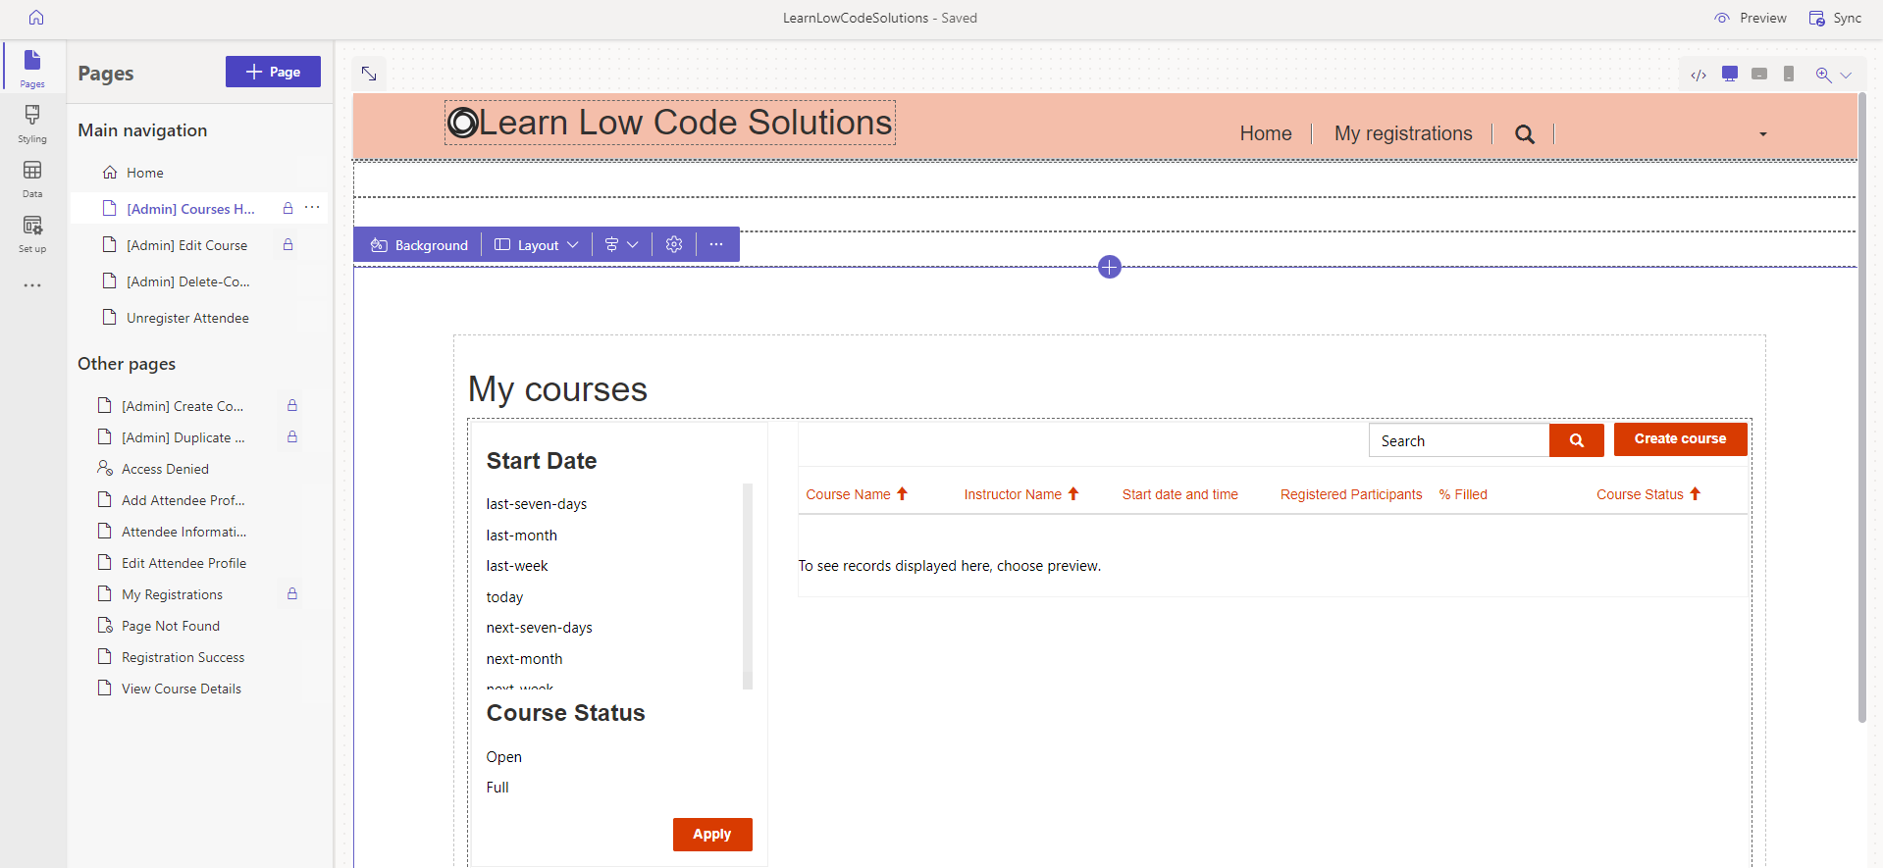

**Screenshot 8. Screenshot showing the default landing page of the website in the design studio**

This Studio has four workspace experiences which are described as below. Each of them are used for different functionalities.

* **Pages workspace** – It allows the user to create power pages. It enables you us to include different components such as PowerApps, Power BI Tiles, Headings Image , Video etc.

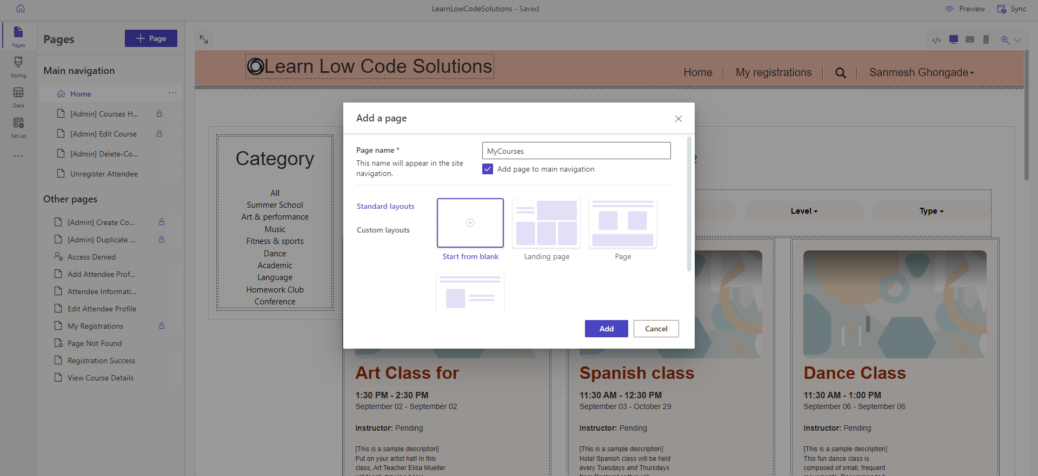

**Screenshot 9. Screenshot showing the creation of new page with blank layout.**

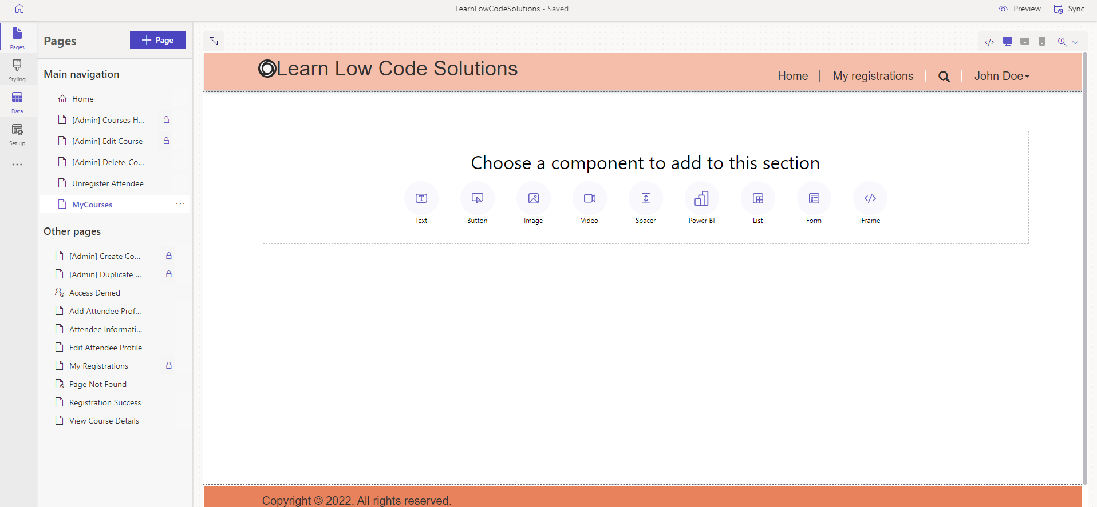

**Screenshot 9. Screenshot showing the different option Components for a New Power Page**

* **Styling workspace -**  Gives users an option of applying global styling. You can apply corporate branding updates, and review the changes in the preview on the right side of the app window. Microsoft has few built-in , styling and colours. One can use them effectively to make customisations as per their branding requirements.

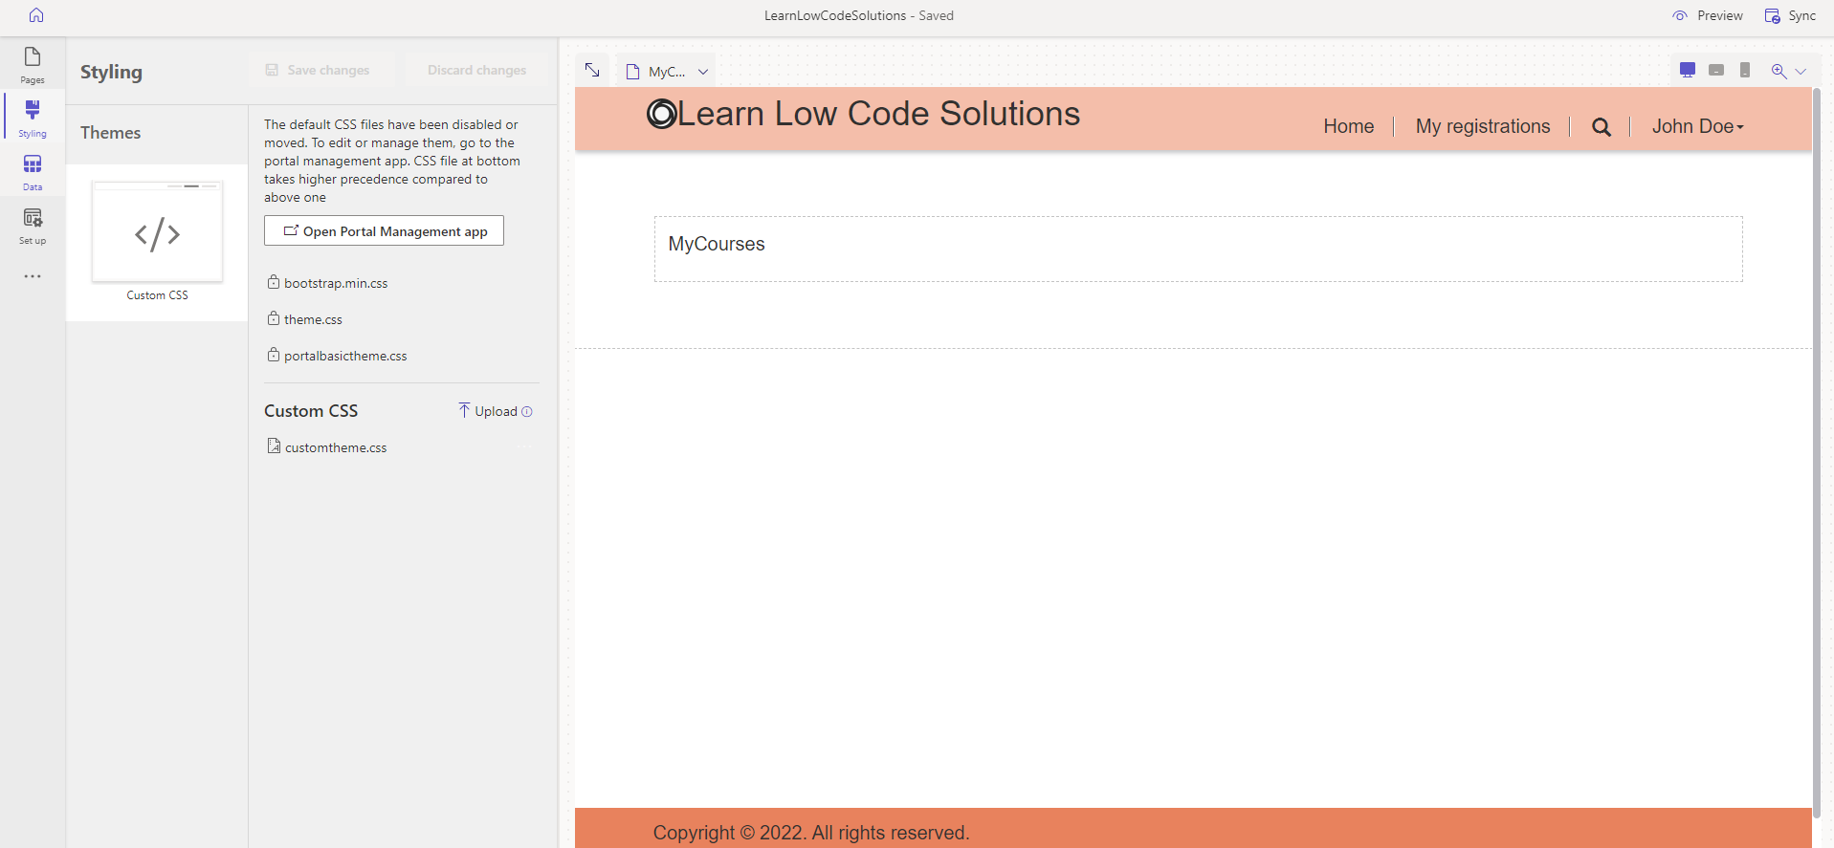

**Screenshot 10. Screenshot showing the different option Components for a New Power Page**

* **Data workspace** lets you easily model, visualize, and manage business data for the site with tables, forms, and lists. You can create and edit Dataverse tables for the site and create new or edit existing model-driven forms and views. Changes made in the Data workspace are stored in the Common data store.

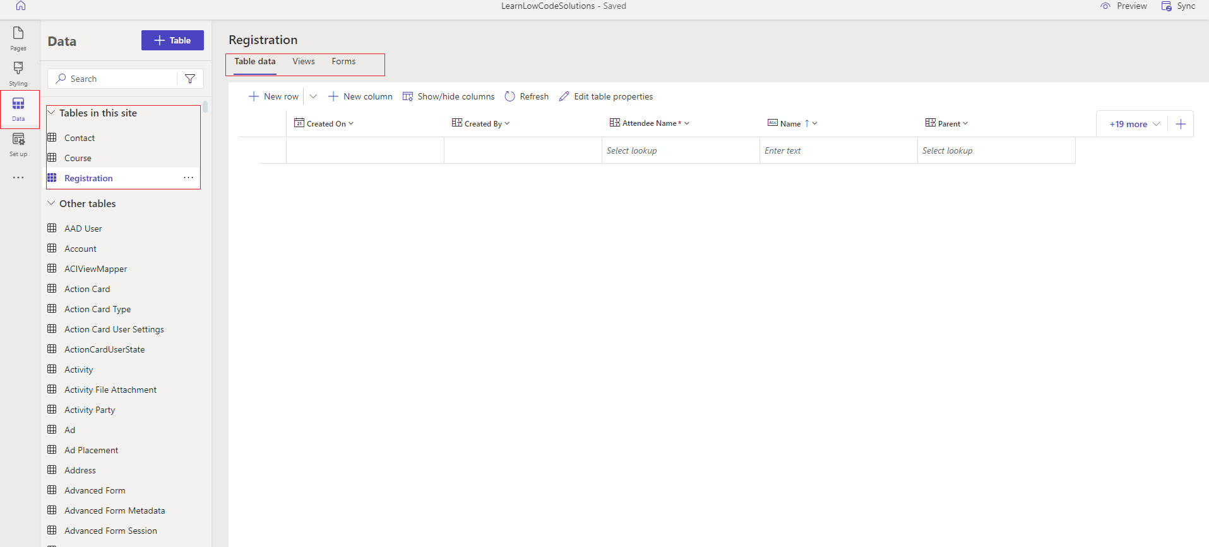

**Screenshot 11. Screenshot displaying the data verse tables**

* **Set up workspace** enables site administrators to configure site settings such as identity providers, security and permissions, go-live configurations, and progressive web app (PWA) settings.

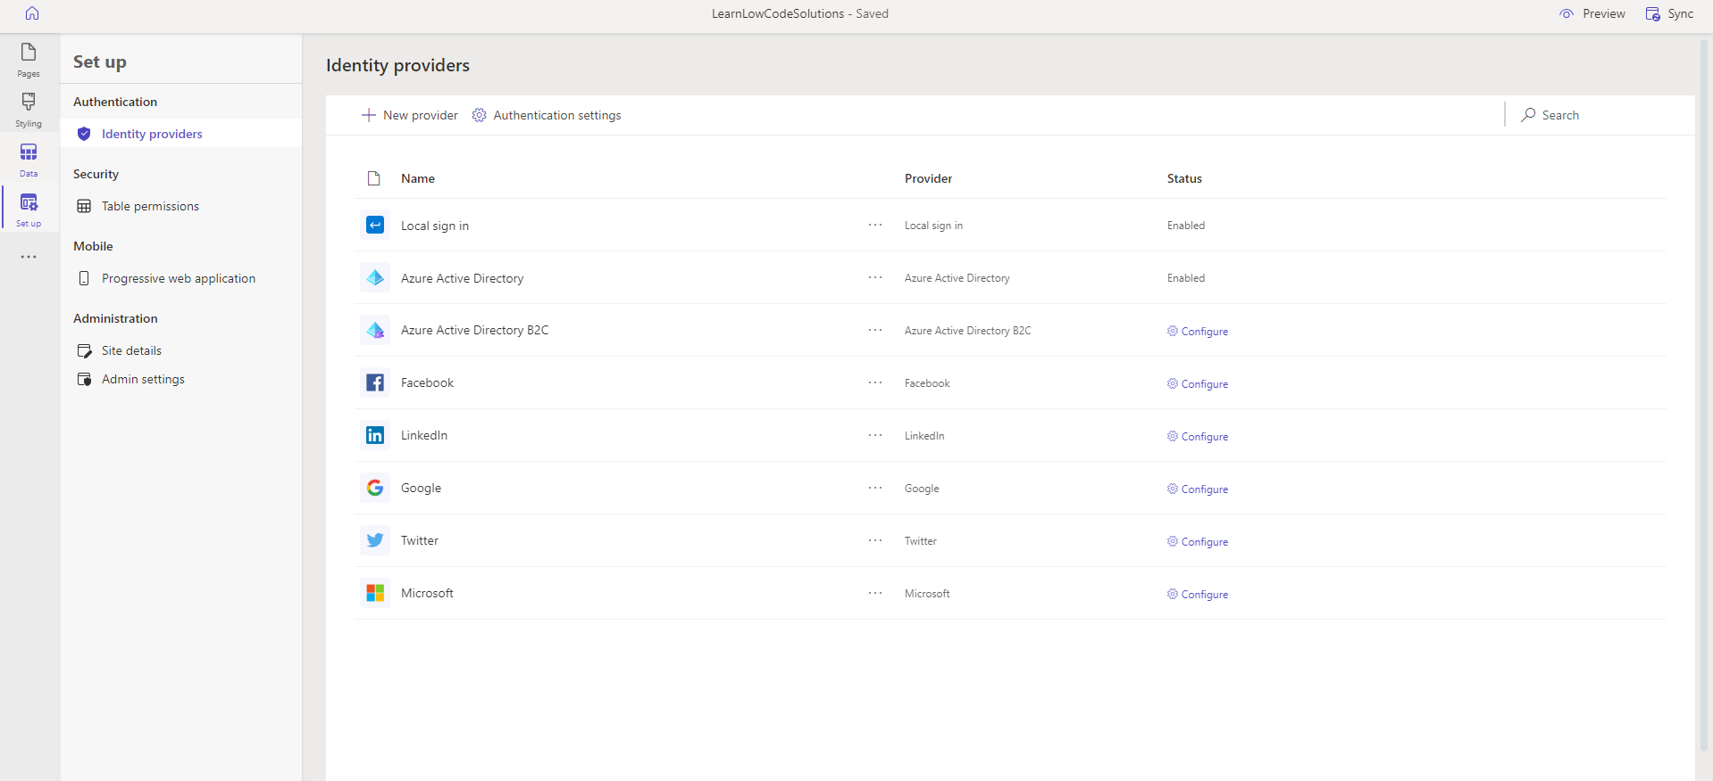

**Screenshot 12. Screenshot displaying setup workspace**

# **Create and Add a Form**

Form can be used to collect data in Power Pages. It is like any other web page form. We can make use of PowerApps also , but in that case one needs to ensure all the access and authentication related things. So , creating a form from data verse is a good option.

**Create a Form**

* 1. Go to the data tab

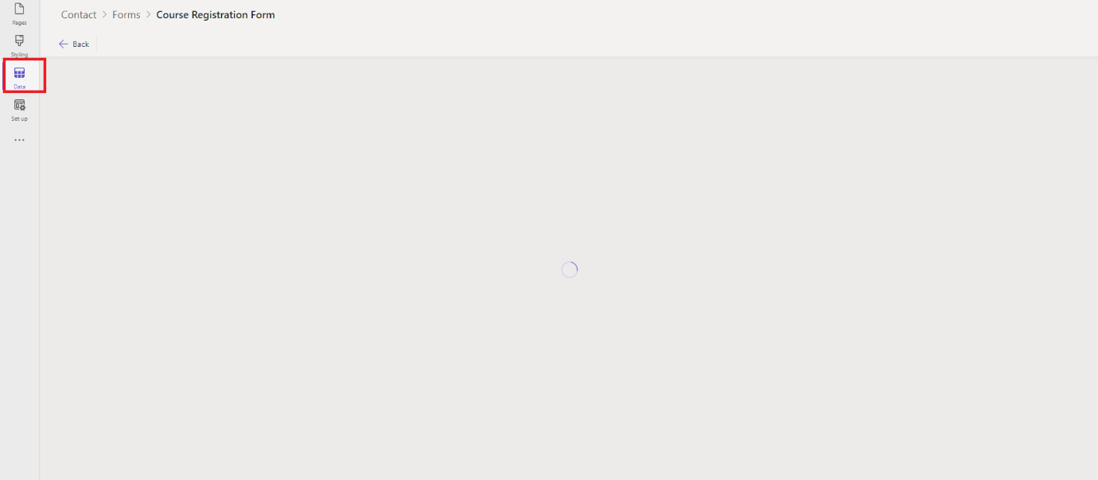

* 1. Select the correct table from which the form is to be created.
  2. Give your Form a Name

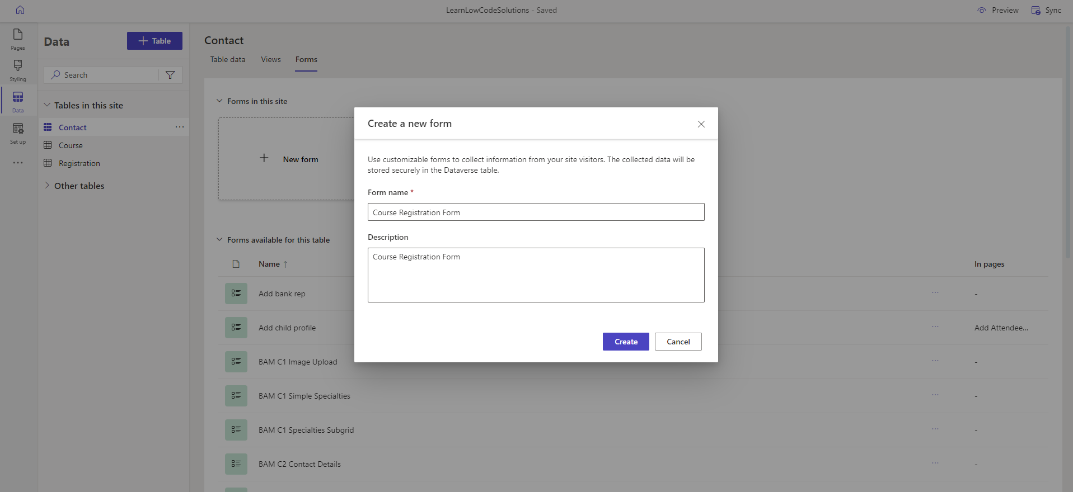

**Screenshot 13. Screenshot with Create Form Option**

* 1. Add the fields of for your form
  2. Save and Publish
  3. The Form is ready to be used in a Page

**Add a Form to your Page**

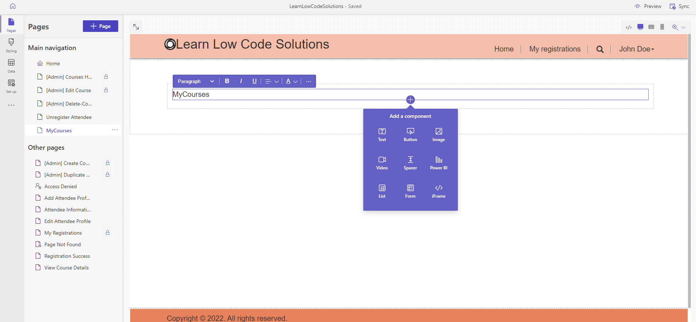

**Screenshot 13. Screenshot with Add Component Option**

1. Go to the page on which you want to insert a Form.
2. Select an option to add a Component
3. Select Form from the options given. That looks as shown in the below screenshot.

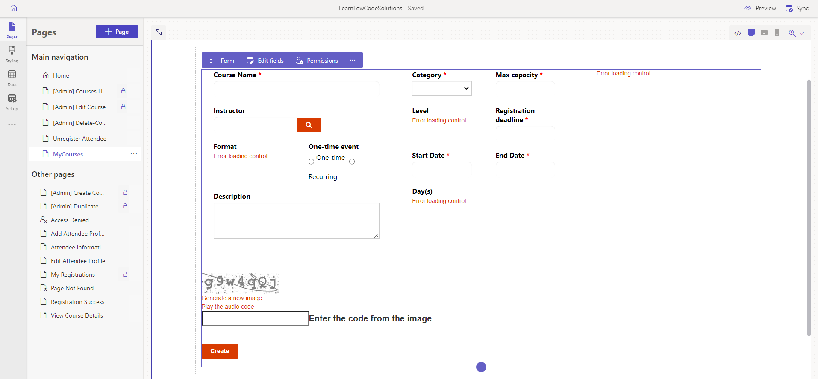

**Screenshot 14. Power Page with a Form**

1. Select the permissions option and give the permissions

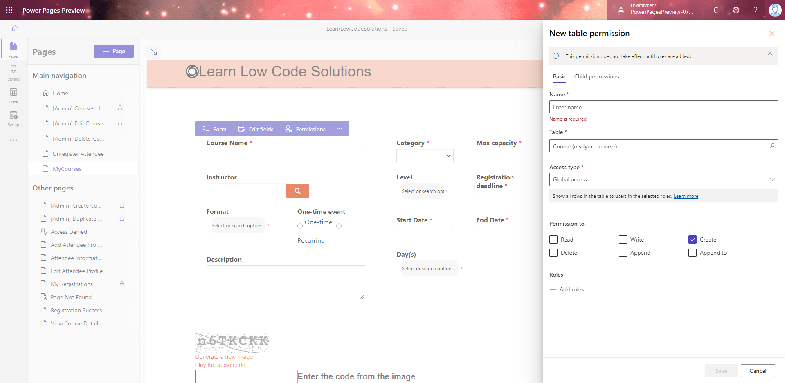

**Screenshot 15. Power Page with a Form**

Once the permissions are set , we are good to use the forms in the power pages.

You'll need to enable [**table permissions**](https://docs.microsoft.com/en-us/power-pages/security/table-permissions) to ensure that users will be able to interact with the data on the forms.

In the same way we can add the Image, Video , iframe etc to the desired part of the page.

# **Permissions in Power Pages**

The most important thing that one has to ensure is that , the websites data is accessed by correct business stakeholders. Power pages has some security feature in place to ensure that the information can be shared with correct stakeholders.

Following are the key components that are used to ensure sharing the information correctly.

* Authenticated user
* Web roles
* Table permissions
* Page permissions

## **Authenticated users**

Power pages gives the flexibility to the users to have many authentication providers such as LinkedIn , Google, Microsoft , Azure Active Directory B2C etc. Power Pages users are represented by Microsoft Data verse contact records Users can be provided access to your site through authentication. We can then decide on the roles and display information based on the role of the users.

## **Web Roles**

Web roles can be created to allow users to perform any special actions or access any protected content and data on the site. Web roles link to users, table permissions, and page permissions. Because contacts can be assigned multiple web roles, they can be provided cumulative access to site resources. All authenticated users (contacts) are automatically assigned to the Authenticated Users web role.

## **Table permissions**

Accessing Dataverse information through [lists](https://docs.microsoft.com/en-us/power-pages/getting-started/add-list), [forms](https://docs.microsoft.com/en-us/power-pages/getting-started/add-form), [Liquid](https://docs.microsoft.com/en-us/power-pages/configure/liquid-overview), and the [Web API](https://docs.microsoft.com/en-us/power-pages/configure/web-api-overview) are by default protected by table permissions. You can configure table permissions to allow different levels of access and privileges to Dataverse records. Table permissions are associated to web roles to provide appropriate access to users.

* **How to Configure Table Permissions**

Table permissions can be configured using the below methods.

* When configuring a list or a form on a page
* From the Set up workspace
* With the Portal Management app

### **Adding table permissions from a list or form**

1. In design studio, go to the page containing the list or form component.
2. Select the form or list component, and then select **Permissions**.

In the **Table permissions** panel that appears, you can manage existing permissions or create a new table permission.

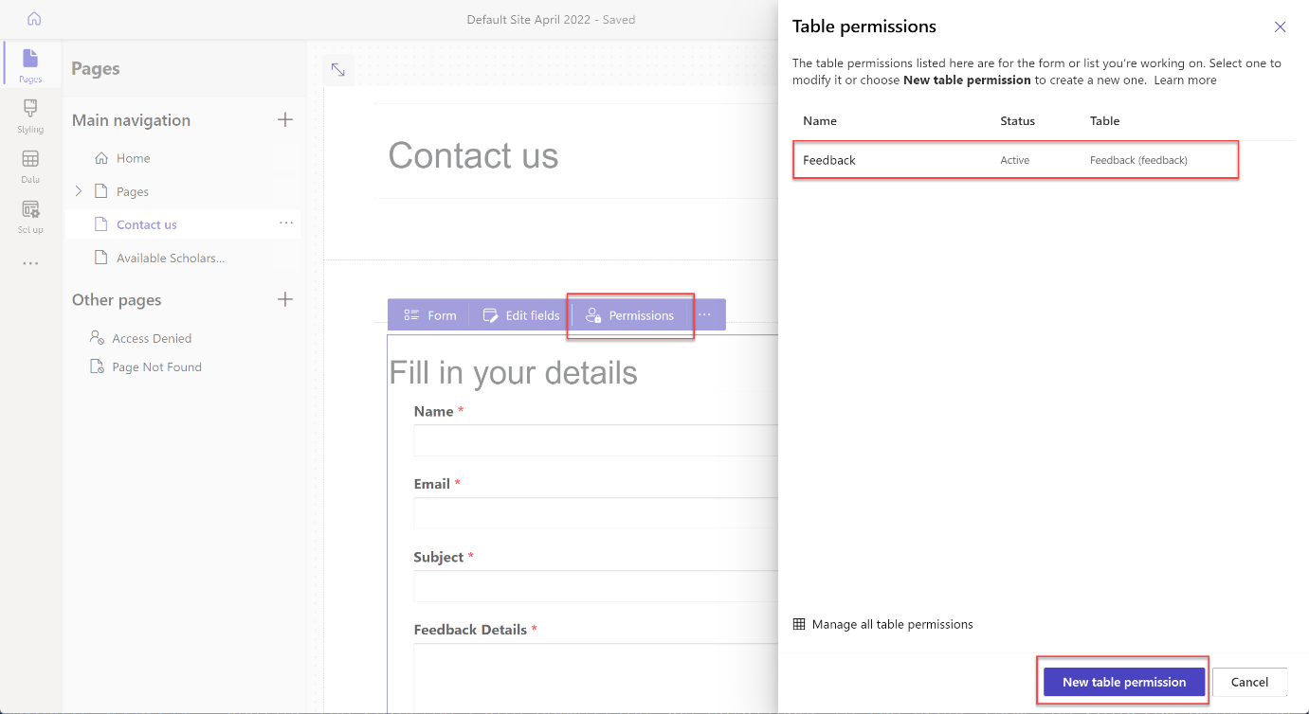

**Screenshot 16. Screenshot showing New Table Permission Creation**

### **Adding table permissions from the Set up workspace**

1. In the design studio on the tool belt, select **Set up**.
2. On the left pane in the **Security** section, select **Table permissions** to add and modify table permissions.

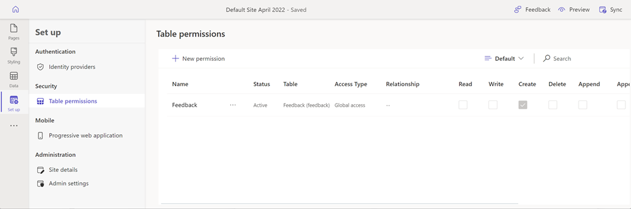

**Screenshot 17. Screenshot showing Table Permissions**

### Adding table permissions from the Portal Management app

1. In the design studio, select the ellipsis (**...**) from the tool belt, and then select **Portal Management**.

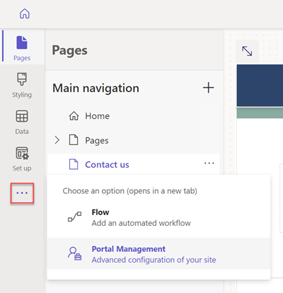

**Screenshot 18. Screenshot showing Managing Permissions from Portal Management**

1. In the Portal Management app on the left pane in the **Security** section, select **Table Permissions.**

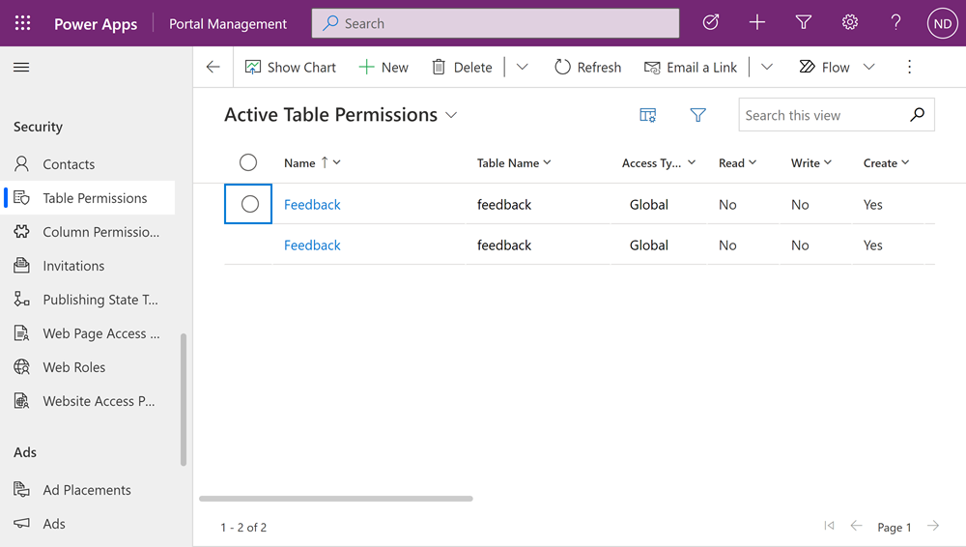

**Screenshot 19. Screenshot showing Permissions for different Entities**

## **Available access types**

The design studio shows four different **Access types**. Depending on the access type you choose, the selected table permission and privileges apply to the users from the selected roles for the following records.

* **Global access** - Applies the selected table permission and privileges to the users from the selected roles for all records.
* **Contact access** - Applies the selected table permission and privileges to the users from the selected role associated to the signed-in user.
* **Account access** - Applies the selected table permission and privileges to the users from the selected role associated to the signed-in user's account.
* **Self access** - Applies the selected table permission and privileges to the users from the selected role for only their own Contact record.

## **Page permissions**

Individual pages containing content or other components can also be protected by configuring page permissions that are associated with web roles to allow access.

## **Additional website security**

Power Pages can be integrated with any web application firewall infrastructure to provide extra protection against common web application attacks. For information on how to integrate it with Azure Front Door web application firewall, see [Set up Azure Front Door with portals](https://docs.microsoft.com/en-us/power-apps/maker/portals/azure-front-door).

# **Licensing**

Power Pages is an evolution of Power Apps portals, and the new features introduced by Power Pages such as the new design studio and templates are in preview for users to try and provide feedback.

It is expected to wait until the general availability of Power Pages later this year to use sites created using the new Power Pages design studio in production scenarios.

All the platform, site admin, and pro developer capabilities inherited by Power Pages from Power Apps portals are generally available and can be used in production scenarios.

Till the general availability of Power Pages, Power Apps portals licenses can be used and Power Pages sites can be converted from trial to production. We can [Convert a portal](https://docs.microsoft.com/en-us/power-apps/maker/portals/admin/convert-portal) in the Power Apps portals documentation.

Follow the documentation for more details on the same.

[**https://docs.microsoft.com/en-us/power-apps/maker/portals/admin/convert-portal**](https://docs.microsoft.com/en-us/power-apps/maker/portals/admin/convert-portal)

**Licensing Details on Power Apps Portals**

The provisioning of PowerApps portals can be done without a specific license requirement. However the licensing in PowerApps portals is dependent on the number on logins done by a user.

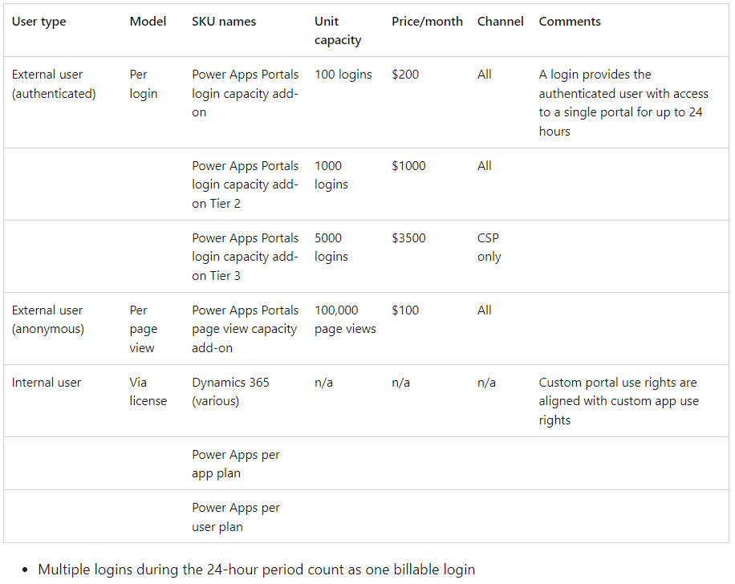

**Screenshot 20.** Table displaying the licensing details for PowerApps portals

**Some FAQ’s related to PowerApps Portals Licensing**

### **1. What exactly is considered a “login” as part of the Power Apps Portals add-on?**

“ Login” can be thought of as “day pass entry” to a PowerApps portal. Once the user logs in into the portal , then subsequent login within the 24 hour windows on different devices are not count as different login , and are not billable.

### **2. Does a single login provide access to multiple Power Apps Portals during the 24-hour period?**

Logins are specific to a single portal. So if you access multiple portals belonging to the same tenant, it will be counted as one login per portal.

### **3. What is the difference between Power Apps Portals and Dynamics 365 Portals in terms of licensing?**

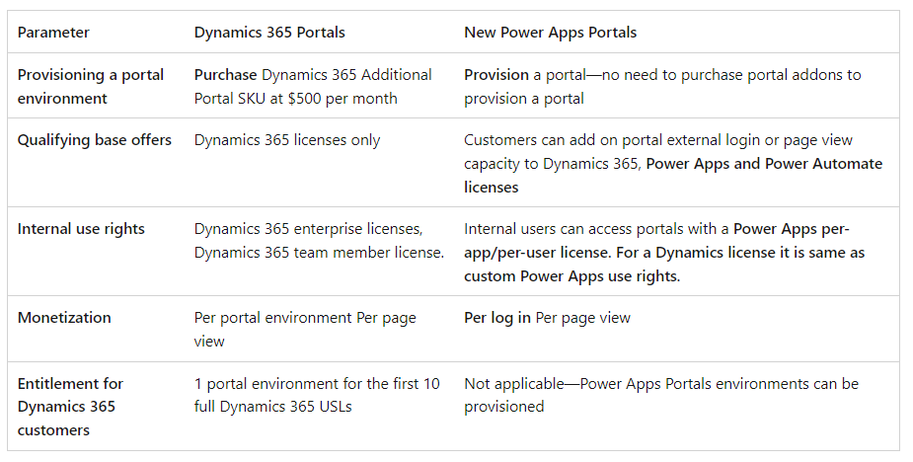

**Screenshot 21.** Table displaying the licensing details for PowerApps portals and Dynamics 365 Portals

### **4. Can I purchase Power Apps Portals add-on licenses with my existing Power Apps P1 or P2 plans or do I have to upgrade to the new plans to benefit from the new portal capability?**

Yes. You can purchase Power Apps Portals add-on capacity if you are an existing Power Apps Plan 1 or Plan 2 customer. You can also purchase this capacity if you are a Dynamics 365 customer.

### **Can you clarify the use rights to Portals for internal users?**

Custom Power Apps Portals use rights: For internal users, use rights to a “custom” portal are aligned with their “custom” Power Apps use rights. For example:

* A Dynamics 365 enterprise application license gets use rights to custom Power Apps applications within the same environment as the Dynamics 365 application. As such, A Dynamics 365 enterprise application license gets use rights to custom Power Apps Portals within the same environment as the licensed Dynamics 365 enterprise application.
* The Team Member license does not get access to custom portal as Team Member licenses do not allow access to a custom app.

### **What is the minimum number of logins and page view that I need to assign to a specific portal?**

Minimum login quantity to be assigned to a portal is 100 logins/month. Once you have assigned 100 logins, you can assign them in units of 1.

For example, if you have 3 portals and bought 4 login packs (400 logins), you can assign them in the following ways:

* Portal 1: 120 (min 100)
* Portal 2: 151 (min 100)
* Portal 3: 129 (min 100)

Page views: Minimum 50,000 per portal. After that you can assign 1 at a minimum.

### **Do unused Power Apps Portals logins carry forward to the next month?**

Portals are licensed at a monthly rate that is based on a customer’s anticipated login volume. Logins are not accumulated as individual assets that would carry forward month to month.

**References**

1. <https://docs.microsoft.com/en-us/power-pages/introduction>

2. https://docs.microsoft.com/en-us/power-pages/capabilities

3. <https://docs.microsoft.com/en-us/power-pages/difference-portals>

4. <https://docs.microsoft.com/en-us/power-pages/security/power-pages-security>

5. <https://docs.microsoft.com/en-us/power-pages/security/create-web-roles>

6. <https://docs.microsoft.com/en-us/power-pages/go-live/assign-licensing>

7. https://docs.microsoft.com/en-us/power-platform/admin/powerapps-flow-licensing-faq#portals

**Document Version History**

|  |  |  |  |  |
| --- | --- | --- | --- | --- |
| **S.No.** | **Version No.** | **Date** | **Prepared By** | **Signed off By** |
| 1 | 1 | 27/7/2022 | Steve |  |
|  |  |  |  |  |
|  |  |  |  |  |
|  |  |  |  |  |